- Project Scope & User Roles

  - Purpose of this Section
This section defines the overall scope of the Waypoint application, identifies the primary user roles, establishes the functional boundaries of the system, and documents the initial assumptions and open questions before detailed system analysis and design begin.

1.2 Product Name
Waypoint

1.3 Product Overview
Waypoint is a web-based employment and hiring event platform that connects job seekers with employers through a centralized application.
The platform enables employees to create and maintain their profiles, search for jobs, apply for suitable positions, register for hiring events, and track their job applications and event registrations.
The platform also enables employers to maintain company information, publish job opportunities, schedule hiring events, review applicants, and manage the hiring process from a centralized dashboard.

1.4 Product Objective
The primary objective of Waypoint is to provide a unified platform where:
- Employees can discover suitable employment opportunities.
- Employees can register for hiring events.
- Employees can manage their professional profiles.
- Employees can monitor their application progress.
- Employers can publish job opportunities.
- Employers can organize hiring events.
- Employers can review applicants and manage candidate progress.
- Both employees and employers can efficiently manage their activities through dedicated portals.

1.5 Business Problem
Organizations often manage job postings, candidate information, hiring events, and application tracking through multiple disconnected systems or manual processes.
Waypoint aims to solve this problem by providing:
- A centralized employment platform.
- Structured job application management.
- Hiring event management.
- Candidate application tracking.
- Employer dashboard for recruitment activities.
- Consistent workflows for both employees and employers.

1.6 Target Users
The current version of Waypoint is designed around two primary user roles.

1.6.1 Employee (Current Project Terminology)
The current project refers to job seekers as Employees. This terminology is retained throughout the design document to remain consistent with the existing project artifacts.
An Employee is responsible for:
- Creating an account
- Logging into the application
- Managing a personal profile
- Uploading a resume
- Maintaining skills and job preferences
- Searching and filtering jobs
- Applying for jobs
- Registering for events
- Tracking job applications
- Managing registered events
- Contacting support

1.6.2 Employer
An Employer represents a company, recruiter, hiring manager, or authorized organization representative responsible for recruitment activities.
An Employer is responsible for:
- Creating an employer account
- Logging into the employer portal
- Managing company information
- Publishing job opportunities
- Scheduling hiring events
- Reviewing candidate applications
- Updating candidate application status
- Managing event registrations
- Viewing recruitment statistics and reports

1.6.3 Administrator (Pending Confirmation)
The current project artifacts do not include an Administrator portal or administrator workflows.
However, a future administrator role may be responsible for:
- Managing platform users
- Verifying employer accounts
- Reviewing inappropriate content
- Managing system reference data
- Handling support requests
- Viewing platform-wide reports
- Monitoring system activities
The inclusion of an Administrator role is pending mentor approval and is currently considered outside the confirmed scope of Version 1.

1.7 User Role Responsibilities

Employee Responsibilities
The Employee shall be able to:
- Register an account.
- Log into the application.
- View the employee dashboard.
- Create and update profile information.
- Upload or update resume information.
- Maintain skills and preferred job roles.
- Maintain salary and employment preferences.
- Search available jobs.
- Filter available jobs.
- View job details.
- Apply for available jobs.
- Submit supporting notes during application.
- Confirm work authorization.
- View submitted applications.
- Track application progress.
- Search available events.
- View event details.
- Register for events.
- Manage registered events.
- Contact customer support.

Employee Restrictions
Employees shall not be permitted to:
- Publish jobs.
- Schedule hiring events.
- View another employee's information.
- Review candidate applications.
- Modify application status.
- View employer-only reports.
- Modify employer information.

Employer Responsibilities
The Employer shall be able to:
- Register an employer account.
- Log into the application.
- View employer dashboard.
- Maintain company information.
- Create job postings.
- Edit job postings.
- Publish job postings.
- Close job postings.
- View applicants.
- Review candidate profiles.
- Review resumes.
- Schedule interviews.
- Update candidate application status.
- Create hiring events.
- Edit hiring events.
- Publish hiring events.
- View event registrations.
- View recruitment statistics.

Employer Restrictions
Employers shall not be permitted to:
- Apply for jobs.
- Register for employee events.
- Modify employee profiles.
- View applicants belonging to another employer.
- Modify another employer's job postings.
- Modify another company's profile.

1.8 Role Permission Matrix
Feature | Employee | Employer
Register Account | ✓ | ✓
Login | ✓ | ✓
View Personal Profile | ✓ | ✓
Edit Personal Profile | ✓ | ✓
View Company Profile | ✗ | ✓ (Own Company)
Edit Company Profile | ✗ | ✓ (Own Company)
Search Jobs | ✓ | ✓ (View Only)
View Job Details | ✓ | ✓
Apply for Jobs | ✓ | ✗
Create Job Posting | ✗ | ✓
Edit Job Posting | ✗ | ✓ (Own Jobs)
Close Job Posting | ✗ | ✓ (Own Jobs)
View Applicants | ✗ | ✓ (Own Jobs)
Update Application Status | ✗ | ✓
Search Events | ✓ | ✓
Register for Events | ✓ | ✗
Create Events | ✗ | ✓
Edit Events | ✗ | ✓ (Own Events)
View Event Registrations | Own Registrations | Own Events
View Reports | ✗ | ✓
Contact Support | ✓ | ✓
*Administrator functionality is pending for confirmation.

1.9 Project Scope

Shared Authentication & Account Management
- Employee registration
- Employer registration
- Role-based login
- Email OTP verification during account registration
- Login authentication
- Forgot Password
- Password Reset using Email OTP
- Change Password for authenticated users
- Logout functionality

Employee Portal
- Employee dashboard
- Employee profile management
- Resume upload and management
- Skills and job preference management
- Job search and filtering
- View job details
- Apply for jobs
- Track job application status
- Search and register for events
- View registered events
- Notification center
- Contact support

Employer Portal
- Employer dashboard
- Employer profile management
- Create, edit and close job postings
- View job postings
- Create and manage hiring events
- View applicants
- Review candidate profiles
- Update application status
- View event registrations
- Notification center
- Basic recruitment reports

Notification Features
The system shall support In-Application Notifications and Email Notifications for both Employees and Employers.
Notifications shall be generated for important system activities, including:
Shared Authentication Notifications
Successful account registration
Email OTP verification
Password reset request
Successful password change

Employee Notifications
- Successful account registration
- Password reset request
- Successful password change
- Job application submission confirmation
- Job application status updates
- Event registration confirmation
- Event updates or cancellations

Employer Notifications
- New job application received
- New event registration received
- Updates related to employer-created jobs
- Updates related to employer-created events

1.10 Scope Boundaries

Employee Data Boundary
Employees may access only:
- Their own profile
- Their own resume
- Their own job applications
- Their own event registrations
- Public job postings
- Public events

Employer Data Boundary
Employers may access only:
- Their own company profile
- Their own job postings
- Their own hiring events
- Applicants related to their own posted jobs
- Registrations related to their own posted events

1.11 Questions for Mentor Review

Employee Module
  - Should the role be named Employee, Candidate, or Job Seeker?

2. Overall System Architecture

2.1 Purpose
The Overall System Architecture defines the major software components of the Waypoint application, their responsibilities, and the interactions between them. It provides a high-level view of the application before database design and implementation begin.

2.2 Architecture Style
Architecture Pattern: Layered Client–Server Architecture
Frontend: React.js
Backend: Spring Boot
Database: MongoDB
Communication Protocol: REST APIs (JSON)

2.3 High-Level Architecture
Layer | Component | Responsibilities
Client Layer | Employee Portal | Allows employees to search jobs, apply for jobs, register for events, manage profiles, and track applications.
Client Layer | Employer Portal | Allows employers to manage profiles, jobs, events, applicants, and recruitment activities.
Presentation Layer | React Frontend | Displays UI, performs client-side validation, and communicates with backend APIs.
API Layer | REST Controllers | Receives frontend requests, validates input, and forwards requests to the service layer.
Business Layer | Service Layer | Implements business rules, processes requests, and coordinates application workflows.
Data Access Layer | Repository Layer | Performs CRUD operations and communicates with MongoDB.
Database Layer | MongoDB | Stores application data and document references.
Supporting Service | Authentication Service | Authenticates users and authorizes access based on roles.
Supporting Service | OTP Service | Generates, validates, expires, and resends OTPs for registration and password reset.
Supporting Service | Email Service | Sends OTPs, password-reset emails, and application notifications.
Supporting Service | Notification Service | Creates in-app notifications and coordinates email notifications.
Supporting Service | Document Storage Service | Stores uploaded resumes and employer logos in local storage while maintaining references in MongoDB.

2.4 Component Responsibilities

React Frontend
Responsibilities
- Display user interfaces.
- Capture user input.
- Perform client-side validations.
- Invoke backend REST APIs.
- Display API responses.
- Navigate users based on assigned roles.

REST Controller Layer
Responsibilities
- Receive HTTP requests.
- Validate request payloads.
- Route requests to appropriate services.
- Return standardized HTTP responses.
- Handle request-level exceptions.

Service Layer
Responsibilities
- Execute business rules.
- Process application logic.
- Validate business constraints.
- Coordinate multiple services.
- Trigger notifications and emails.
- Return processed data to controllers.
Repository Layer
Responsibilities
- Perform Create, Read, Update, and Delete operations.
- Query MongoDB collections.
- Execute search and filtering.
- Persist application data.
- Retrieve related documents.

MongoDB Database
Responsibilities
- Store application data.
- Maintain document references.
- Store notification records.
- Store OTP records.
- Maintain data consistency.

Authentication Service
Responsibilities
- Authenticate users during login.
- Authorize users based on assigned roles.
- Manage authentication tokens.
- Protect secured APIs.

OTP Service
Responsibilities
- Generate One-Time Passwords.
- Validate OTPs.
- Enforce OTP expiration.
- Handle OTP resend requests.
Email Service
Responsibilities
- Send registration OTPs.
- Send password-reset emails.
- Send notification emails.
- Deliver application-related communications.
Notification Service
Responsibilities
- Generate in-app notifications.
- Send email notifications.
- Maintain notification history.
- Retrieve user notifications.
Document Storage Service
Responsibilities
- Store uploaded resumes.
- Store employer logos.
- Validate uploaded documents.
- Maintain document references.

2.5 Proposed Technology Stack
Component | Technology
Frontend | React.js
Backend | Spring Boot
Database | MongoDB
Authentication | Spring Security + JWT
Password Encryption | BCrypt
Email Service | Spring Boot JavaMailSender
OTP Service | Custom Spring Boot Service
Notification Service | Spring Boot Notification Module
Document Storage | Local Server Storage
Build Tool | Maven
Version Control | Git & GitHub

2.6 Component Interaction Flow
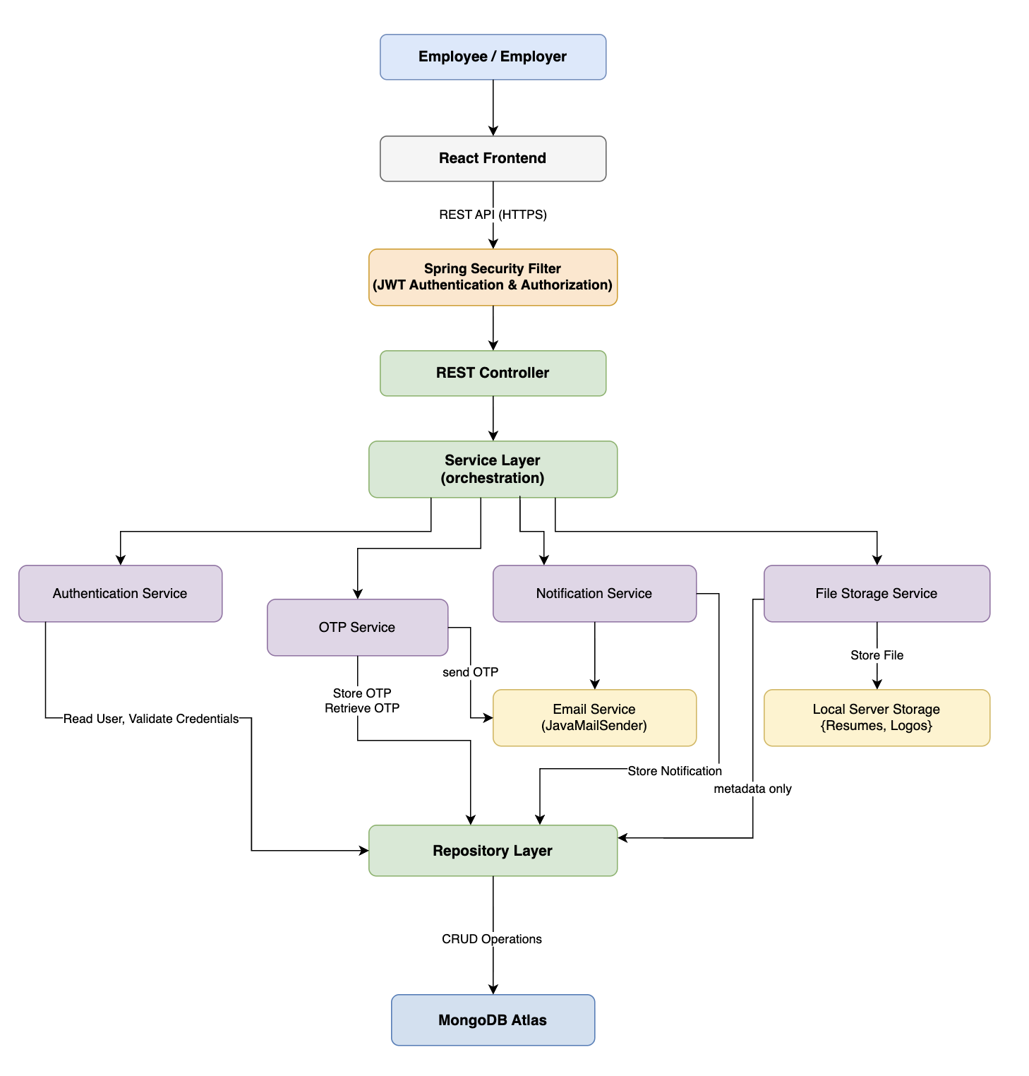

3. Entity Relationship Diagram (ERD)

3.1 Purpose
The Entity Relationship Diagram (ERD) represents the logical database structure of the Waypoint application. It identifies the major business entities, their attributes, and the relationships between them. The ERD serves as the foundation for the MongoDB collection design and ensures that both frontend and backend development follow a consistent data model.
3.2 Design Principles
The database has been designed based on the following principles:
- MongoDB document-based architecture.
- Shared authentication through a common User collection.
- Separate profile collections for Employees and Employers.
- Normalized business entities to minimize data duplication.
- MongoDB document references (REF) used to establish relationships between collections.
- Audit fields (createdAt, updatedAt) maintained in all primary collections.
- One-to-many relationships modeled using separate collections such as JobApplication and EventRegistration.

3.3 Database Collections
Collection | Purpose
User | Stores authentication and account information for all users.
EmployeeProfile | Stores employee personal and professional profile details.
EmployerProfile | Stores employer/company profile information.
Job | Stores job postings created by employers.
JobApplication | Stores applications submitted by employees for jobs.
Event | Stores hiring events created by employers.
EventRegistration | Stores employee registrations for events.
Notification | Stores in-app notifications for users.
OTPVerification | Stores temporary OTP verification details for registration and password reset.
ContactSupport | Stores support tickets raised by users.

3.4 Entity Relationship Diagram
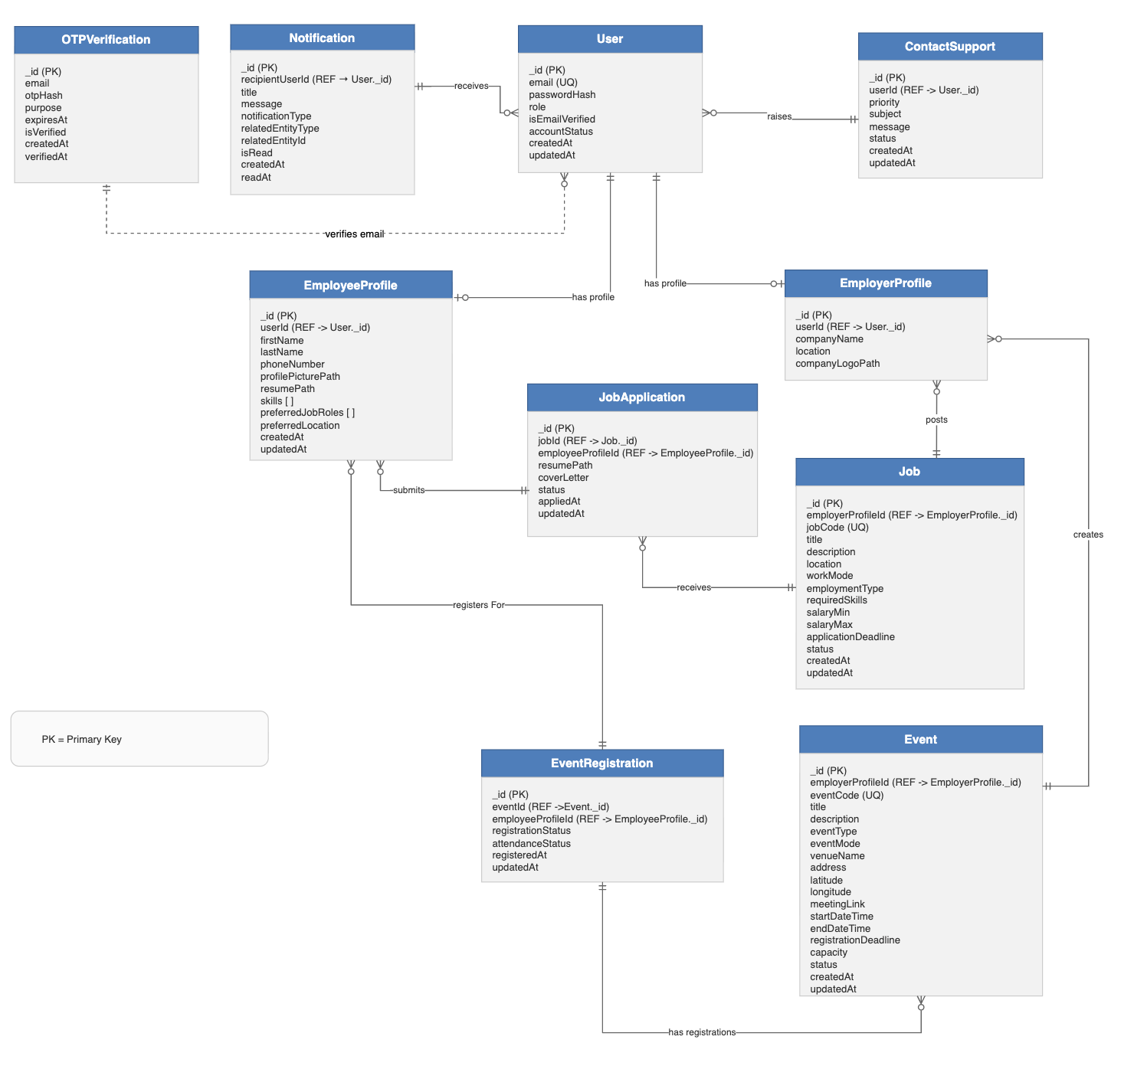
The application uses MongoDB document references instead of traditional SQL foreign keys. Relationships are maintained using ObjectId references (userId, jobId, employeeProfileId, etc.) to improve flexibility while preserving data integrity.

3.5 Relationship Summary
Parent Entity | Relationship | Child Entity | Cardinality
User | Has Profile | EmployeeProfile | One User → One EmployeeProfile (based on user role)
User | Has Profile | EmployerProfile | One User → One EmployerProfile (based on user role)
EmployerProfile | Posts | Job | One EmployerProfile → Many Jobs
EmployeeProfile | Submits | JobApplication | One EmployeeProfile → Many Job Applications
Job | Receives | JobApplication | One Job → Many Job Applications
EmployerProfile | Creates | Event | One EmployerProfile → Many Events
EmployeeProfile | Registers For | EventRegistration | One EmployeeProfile → Many Event Registrations
Event | Has Registrations | EventRegistration | One Event → Many Event Registrations
User | Receives | Notification | One User → Many Notifications
User | Raises | ContactSupport | One User → Many Support Requests

3.6 MongoDB Reference Strategy
Since the application uses MongoDB, relationships are maintained using document references rather than relational foreign keys.
Fields marked with REF represent references to the primary key (_id) of another collection.
Referential integrity is validated within the Spring Boot Service Layer.

3.7 Assumptions
- Every User can have only one profile based on their assigned role.
- A User can either be an Employee or an Employer in Version 1 of the application.
- One Employer can create multiple Jobs and Events.
- One Employee can apply for multiple Jobs and register for multiple Events.
- OTP Verification is maintained as an independent collection and linked using the registered email address during account verification and password reset.

